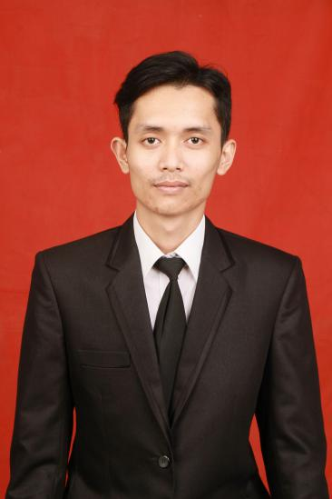

ARIZKI, S.H

I have more than 5 years of experience working in the field sales & marketing and taking DevOps Engineer course. Have a passion for seeking a new opportunit

PROFESIONAL SKILL

WORK EXPERIENCE

TL at POWER SWICH

* Monitoring performace SPG/SPB
* Make daily sales report
* Hiring SPG/SPB

PT. GRAMEDIA ASRI MEDIA

(SALES SUPERINTENDENT 2017-Present)

* Make Action Plant
* Monitoring Operation Store
* Analisys data income
* Make monthly budget
* Sales
* AWS (AMAZON WEB SERVICES)
* KUBERNETES
* SALES & MARKETING
* MICROSOFT OFFICE

PERSONAL SKILLS

* Reliable and Profesional
* Organized
* Work with Team or Individual
* Time Management
* Motivated

CONTACT

EDUCATION

* Bachelor of law from Pasundan University (2016)
* School of DevOps Cilsy (2021)

WhatsApp: +62822-3970-8608

Call : +62813-8576-8282

Email : [arizki.ynwa@gmail.com](mailto:arizki.ynwa@gmail.com)

HOBBY

Trekking

SOCIAL

Instagram: @arizkiiiii

Linkedin :

linkedin.com/in/arizki-0a9a50181/